**CHAPTER 1**

**INTRODUCTION**

The Auto-Spare Part Management is developed for sale/purchase organization. This system manages customer, product, sales order, and dealer and purchase order. It provides a platform to the trader to automate their record keeping. The purpose of this project is to develop an application program to reduce the manual work for managing inventory, product, customer, dealer and orders. This project is built to help admin in managing his organization. Admin can store customer details in the database. Next time when customer comes in then there is no need to enter his details again. It can selected from the list displaying all customer

Functions of Auto-Spare Part Management:

1.Admin can store all customer and dealer record.

2.This application keeps tracks of all the products being sold in the organization.

3.This system provides facility of making sales and purchase order.

4.All products, customer and dealer record is maintained as master data. User can selected these from display list while making sales order and purchase order.

The main reason to build this project is to provide the seller a in-look of the shop. This project wills the guide owner to the products available in the shop and which are required to order from the sellers. By this, shopkeeper doesn’t have to keep track of the records manually. The more comfortable users of computerized systems were mostly users with a fair accounting knowledge.

**CHAPTER 2**

**REQUIREMENTS ANALYSIS**

The Requirements analysis was done to ascertain the type of sales management systems used by the SMEs and users experiences with the existing systems. This process led to the identification of two major types of systems namely; manual systems and computerized systems.

In response to questions about which of the two types of systems was preferred most of the businesses using the manual systems where daily sales books are maintained chose the computerized systems as most effective and convenient but cited factors such as difficulty of use, cost of acquiring full package and technical functions as reasons for not using them.

It was also noted that some of the users of computerized systems also kept daily sales books, explaining that their sales persons needed a more formal training to be able to use the system effectively and for that matter it was convenient to keep a daily sales book to help identify error entries and sales misrepresentations.

The more comfortable users of computerized systems were mostly users with a fair accounting knowledge. In some cases business owners left the entire system to the accountant who was more familiar with the system, a situation some said possess a business risk. Deductions from the requirements analysis show that ease of use and knowledge prerequisite are the main reasons why most SMEs are not able to adopt computerized systems fully for tracking and managing their sales processes. This situation makes them stick to old and sometimes wasteful methods of tracking sales. The effect of this is loss of profits due to poor record keeping. Hence we sought to build a sales management system with friendly and interactive user interfaces which is easy to learn and use. However, the design does not compromise the security or integrity of business processes, and is intended to streamline transactions to eliminate user level errors such as misrepresentation of sales, uncaptured transactions and error entries

**2.1 SOFTWARE REQUIREMENTS:**

1. Operating System: Windows 7 or above
2. Programming Language: JAVA SE 8.0
3. Front-end Development: HTML-CSS
4. Back-end Development: PHP

**2.2 HARDWARE REQUIREMENTS**

1. Processor – Pentium IV or above
2. RAM – 2 GB or more
3. Hard disk – 3 GB or more
4. LAN NETWROK / WIRELESS

**CHAPTER 3**

**DESIGN**

**3.1 System Design**

An System Design is  the process of defining the [architecture](https://en.wikipedia.org/wiki/Systems_architecture), [product design](https://en.wikipedia.org/wiki/Product_design), modules, interfaces, and [data](https://en.wikipedia.org/wiki/Data) for a [system](https://en.wikipedia.org/wiki/System) to satisfy specified [requirements](https://en.wikipedia.org/wiki/Requirement). Systems design could be seen as the application of [systems theory](https://en.wikipedia.org/wiki/Systems_theory) to [product development](https://en.wikipedia.org/wiki/Product_development).

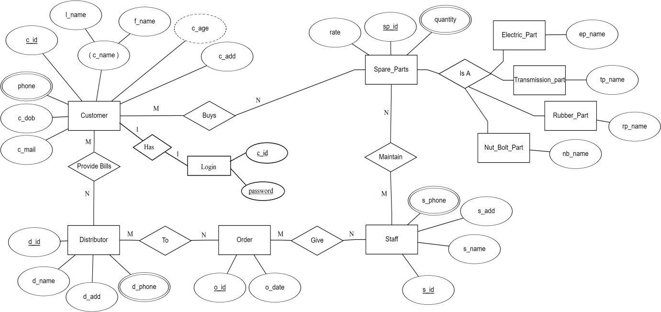

**Figure 2.1.1**:ER Diagram of Auto-Spare Part Management

ER Diagram in DBMS is widely used to describe the conceptual design of databases. It helps both users and database developers to preview the structure of the database before implementing the database.

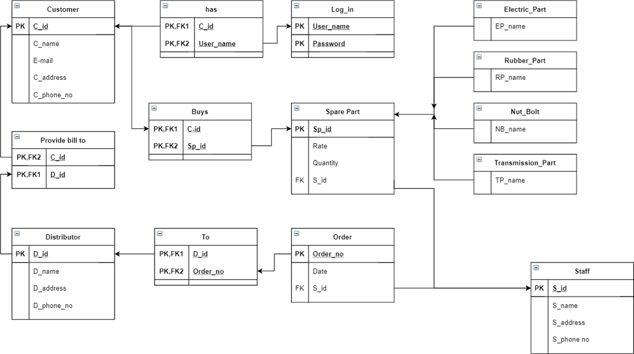**Figure 2.1.2**: schema diagram for Auto-spare parts management

A schema diagram is a diagram which contains entities and the attributes that will define that schema. A schema diagram only shows us the database design. It does not show the actual data of the database. Schema can be a single table or it can have more than one table which is related.

**CHAPTER 4**

**IMPLEMENTATION**

**4.1 INTRODUCTION TO FRONT END TOOL**

For frontend we have used HTML, CSS and JavaScript.

**1.HTM L**

(Hyper Text Markup Language) is the most basic building block of the Web. It defines the meaning and structure of web content. Other technologies besides HTML are generally used to describe a web page's appearance/presentation (CSS) or functionality/behavior (JavaScript).

"Hypertext" refers to links that connect web pages to one another, either within a single website or between websites. Links are a fundamental aspect of the Web. By uploading content to the Internet and linking it to pages created by other people, you become an active participant in the World Wide Web.

HTML uses "markup" to annotate text, images, and other content for display in a Web browser. HTML markup includes special "elements" such as <head>, <title>

An HTML element is set off from other text in a document by "tags", which consist of the element name surrounded by "<" and ">". The name of an element inside a tag is case insensitive. That is, it can be written in uppercase, lowercase, or a mixture. For example, the <title> tag can be written as <Title>, <TITLE>, or in any other way.

**2. CSS**

Cascading Style Sheets (CSS) is a style sheet language used for describing the presentation of a document written in a markup language such as HTML.CSS is a cornerstone technology of the World Wide Web, alongside HTML and JavaScript.

CSS is designed to enable the separation of presentation and content, including layout, colors, and fonts. This separation can improve content accessibility; provide more flexibility and control in the specification of presentation characteristics; enable multiple web pages to share formatting by specifying the relevant CSS in a separate . Css file, which reduces complexity and repetition in the structural content; and enable the Css file to be cached to improve the page load speed between the pages that share the file and its formatting.

Separation of formatting and content also makes it feasible to present the same markup

page in different styles for different rendering methods, such as on-screen, in print, by voice (via speech-based browser or screen reader), and on Braille-based tactile devices. CSS also has rules for alternate formatting if the content is accessed on a mobile device.

The name cascading comes from the specified priority scheme to determine which style rule applies if more than one rule matches a particular element. This cascading priority scheme is predictable.

The CSS specifications are maintained by the World Wide Web Consortium (W3C). Internet media type (MIME type) text/css is registered for use with CS S by RFC 2318 (March 1998). The W3C operates a free CSS validation service for CSS documents.

In addition to HTML, other markup languages support the use of CSS including XHTML, plain XML, SVG, and XUL.

**3. JAVASCRIPT**

Often abbreviated JS, is a programming language that is one of the core technologies of the World Wide Web, alongside HTML and CSS. Over 97% of websites use JavaScript on the client side for web page behavior, often incorporating third-party libraries. All major web browsers have a dedicated JavaScript engine to execute the code on user devices.

JavaScript is a high-level, often just-in-time compiled language that conforms to the ECMAScript standard. It has dynamic typing, prototype-based object-orientation, and first- class functions. It is multi-paradigm, supporting event-driven, functional, and imperative programming styles. It has application programming interfaces (APIs) for working with text, dates, regular expressions, standard data structures, and the Document Object Model (DOM).

The ECMAScript standard does not include any input/output (I/O), such as networking, storage, or graphics facilities. In practice, the web browser or other runtime system provides JavaScript APIs for I/O.

JavaScript engines were originally used only in web browsers, but are now core components of some servers and a variety of applications like the most important Node.js.

Although Java and JavaScript are similar in name, syntax, and respective standard libraries, the two languages are distinct and differ greatly in design.

**4.2 BACKEND TOOLS**

For backend we have used PHP, MySql as database and apache using Xampp for the server in localhost.

**1. PHP**

Is a general-purpose scripting language geared towards web development. It was originally created by Danish-Canadian programmer Rasmus Lerdorf in 1994. The PHP reference implementation is now produced by The PHP Group. PHP originally stood for Personal Home Page, but it now stands for the recursive initials PHP: Hypertext Preprocessor.

PHP code is usually processed on a web server by a PHP interpreter implemented as a module, a daemon or as a Common Gateway Interface (CGI) executable. On a web server, the result of the interpreted and executed PHP code – which may be any type of data, such as generated HTML or binary image data – would form the whole or part of an HTTP response. Various web template systems, web content management systems, and web frameworks exist which can be employed to orchestrate or facilitate the generation of that response. Additionally, PHP can be used for many programming tasks outside the web context, such as standalone graphical applications and robotic drone control. PHP code can also be directly executed from the command line.

The standard PHP interpreter, powered by the Zend Engine, is free software released under the PHP License. PHP has been widely ported and can be deployed on most web servers on a variety of operating systems and platforms.

The PHP language evolved without a written formal specification or standard until 2014, with the original implementation acting as the de facto standard which other implementations aimed to follow. Since 2014, work has gone on to create a formal PHP

**2.MySQL**

Is an open-source relational database management system (RDBMS). Its name is

a combination of “My”, the name of co-founder Michael Widenius’s daughter and “SQL”,the abbreviation of Structured Query Language. A relational database organizes data into one or more data tables in which types may be related to each

other; these relations helpnstructure the data. SQL is a language programmers

use to create, modify and extract data from the relational database, as well as control user database.

MySQL was owned and sponsored by the Swedish company MySQL AB, which was bought by Sun Microsystems (now Oracle Corporation). .In 2010, when Oracle acquired Sun, Widenius forked the open-source MySQL project to create Maria DB.

**4.2 CONNECTIVITY TO THE DATABASE**

Xampp using Apache is Web Server on Localhost on the same IP. For connectivity, we use XAMPP app so that we can get the localhost connection to the web browser. In XAMPP, we start the APACHE and MYSQ L modules.

As a Web server, Apache is responsible for accepting directory (HTTP) requests from internet users and sending them their desired information in the form of files and web pages. Much of the Web’s software and code is designed to work along with Apache’s features.

MySQL is a relational database management system based on SQL - Structured Query Language. Here we are using this server in XAMPP for connecting our database frontend

**CHAPTER 5**

**SNAPSHOTS**

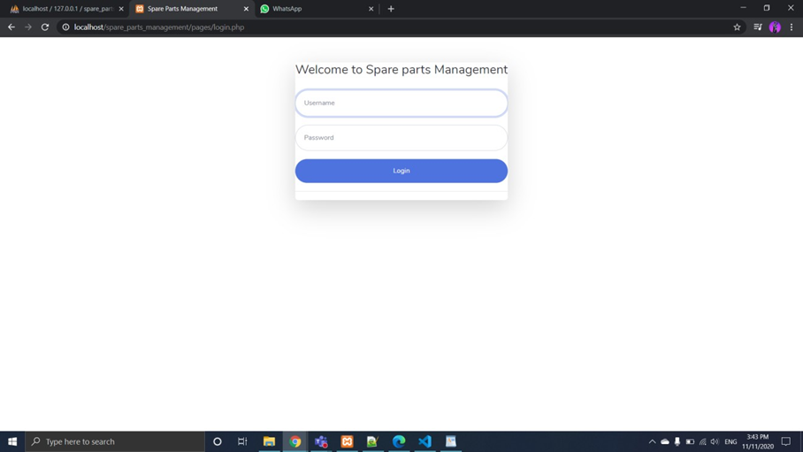 Screenshot 5.1: login page.

This is over login page. There are two types of login one for manager and one for cashier. The following screenshots is for manager login.

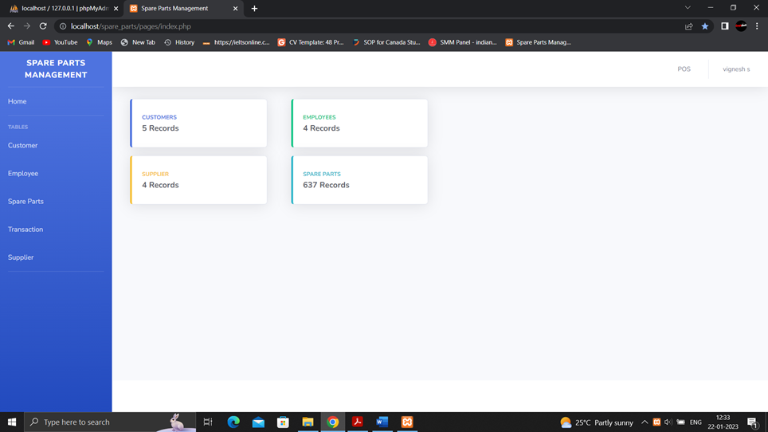Screenshot 5.2: Home page.

This is our home page. After entering correct username and password the manager will redirect to this page.

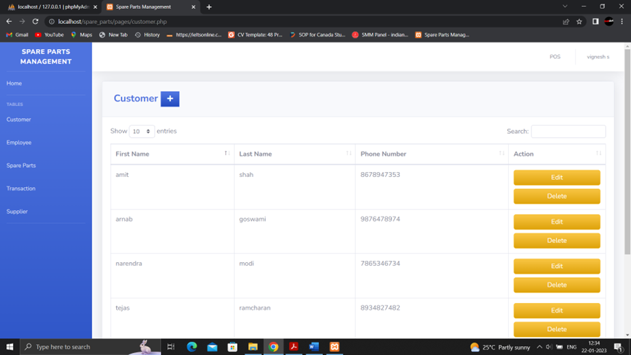Screenshot 5.3: Customer page

This is customer page. Here you will information about the entire customer who has buy product from you. When you click on edit, you can change the information about the customer.

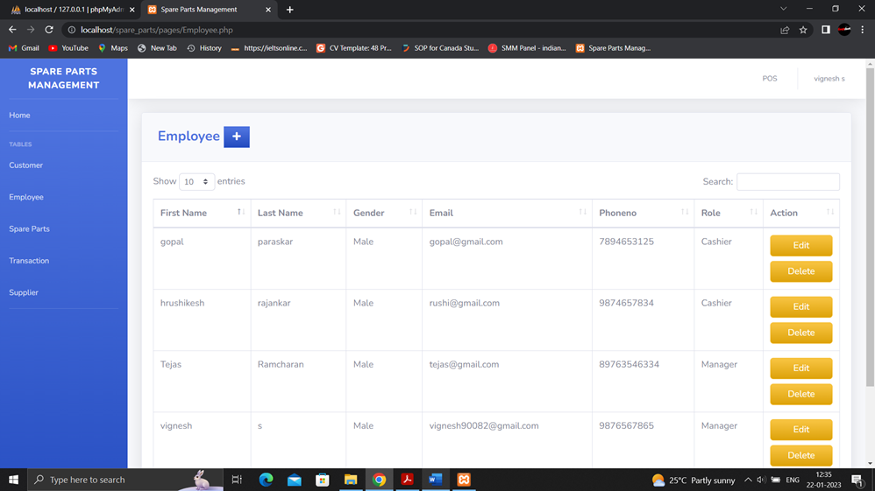Screenshot 5.4: Employee page.

This is our employee page here you can add or remove employee name who are working with you or who was working with you.

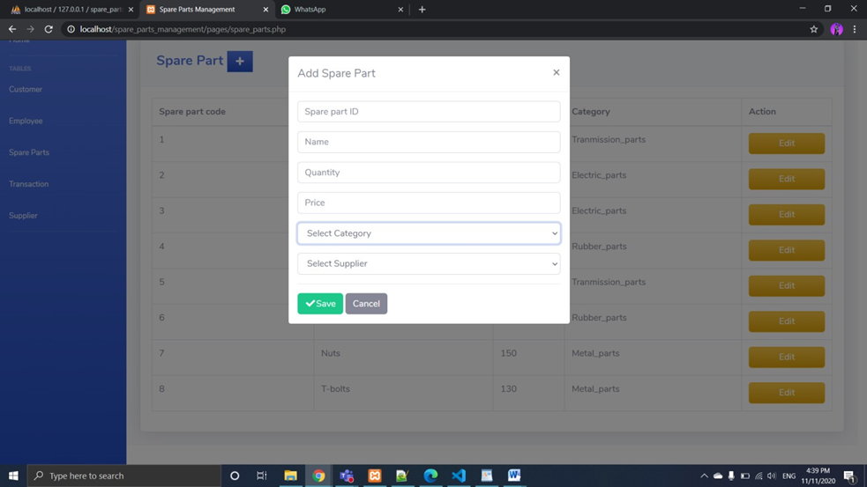Screenshot 5.5: Add spare parts.

Here you add name of new spare part with their details.

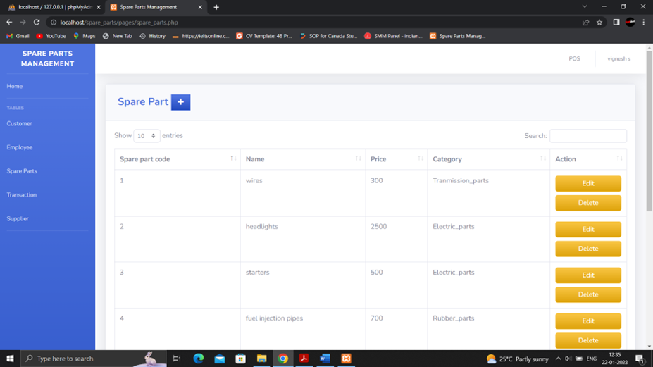Screenshot 5.6: Information of product.

This is the page where you get all information about product you have in your shop.

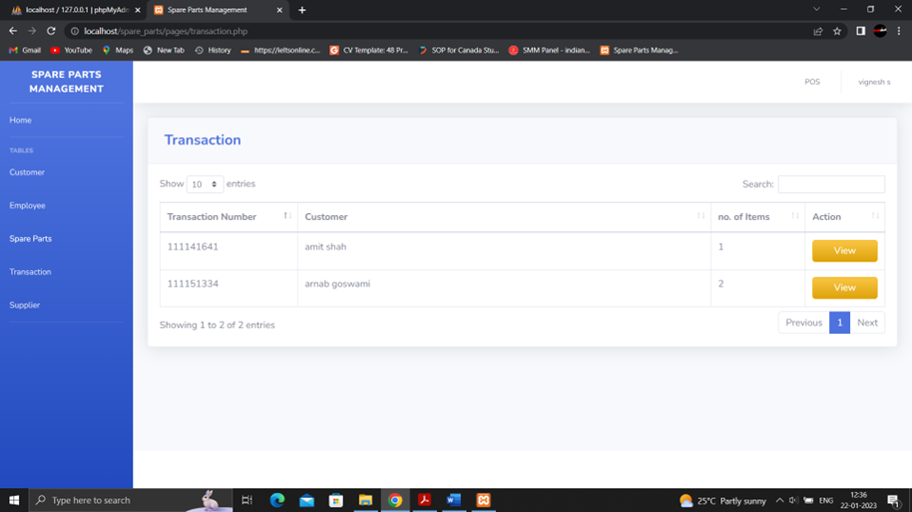Screenshot 5.7: Transaction details.

Here you will get transaction details of the entire customer. This will also show how much of their money are remaining to pay by clicking on view as below.

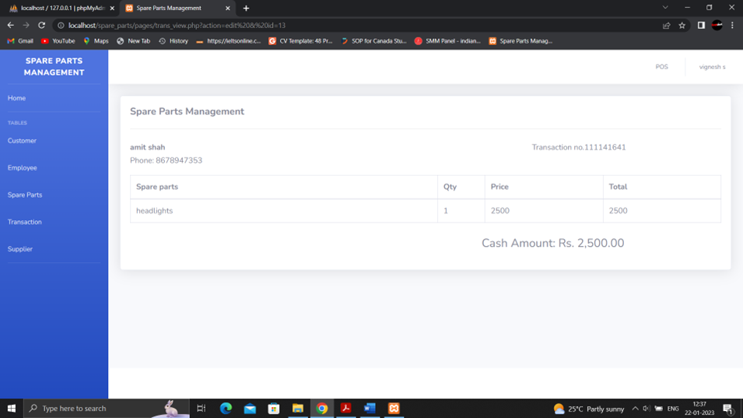Screenshot 5.8: Bill details.

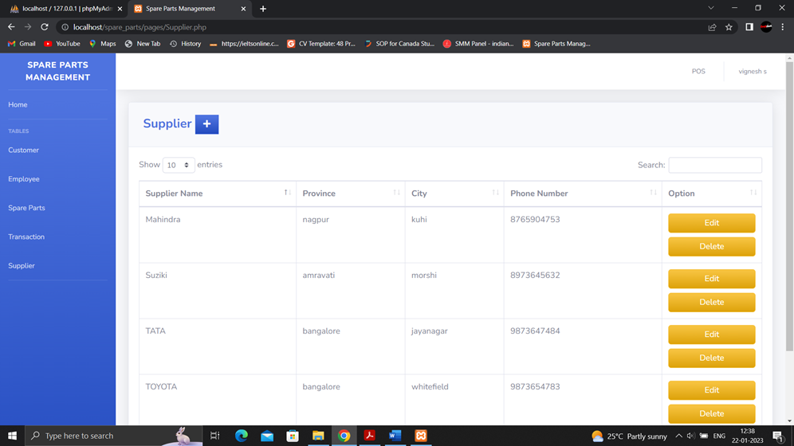Screenshot 5.9: Supplier Details.

This page will show all the details of the supplier from whom we buys product to sell.

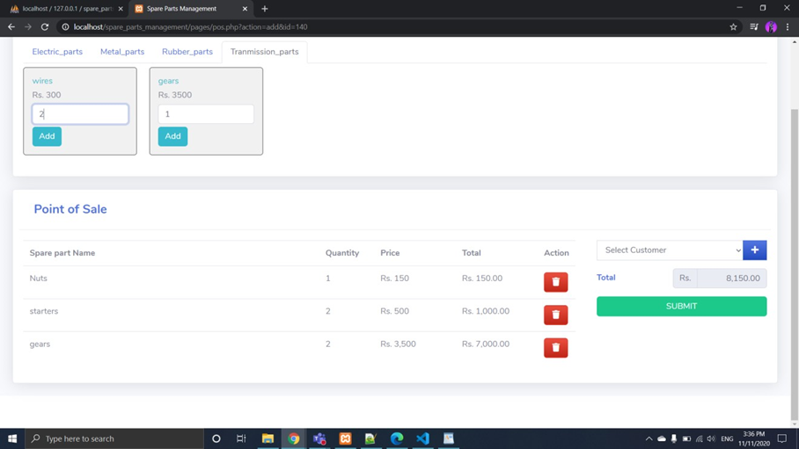Screenshot 5.10: POS Details.

On right hand-side top you will find POS(point of sale) where we have created four categories. Here you add the product how much you want. If you have new user you can add on plus and add the user and create bill.

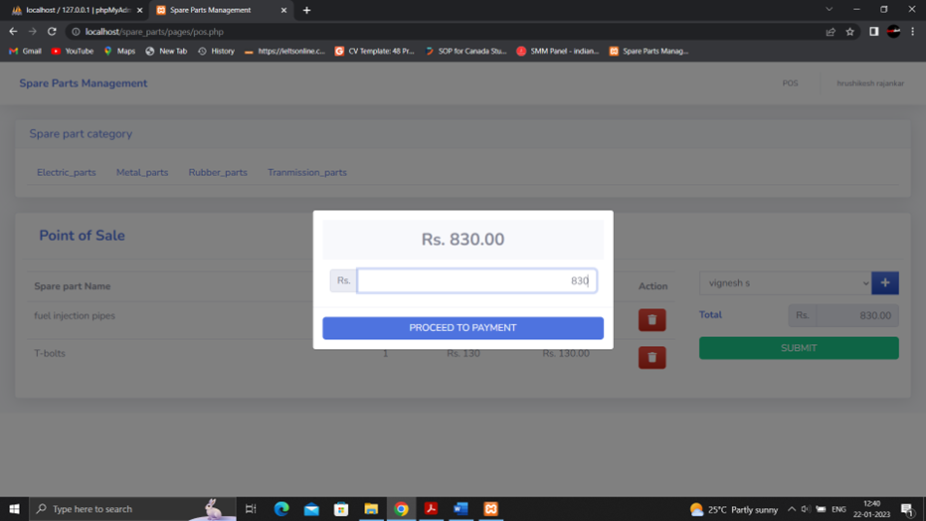Screenshot 5.11: Payment page.

Here you enter amount to pay to the owner.

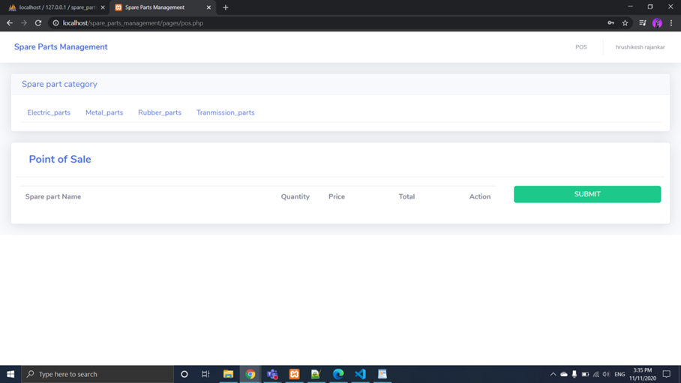Screenshot 5.12: Cashier Login.

This page is for only cashier. Whenever, cashier login he will redirect to this page. Access of the cashier is limit to this page.

Screenshot 5.13: Customer Bill details.

Here, cashier add the customer and make the bill.

Screenshot 5.14: XAMPP Control Panel.

Showing XAMPP Control Panel. Which manages our localhost framework. Using this console, we are able to run the Website on our system with UR L as our local-host address.

➢ The below given figure shows the designation table creation and insertion.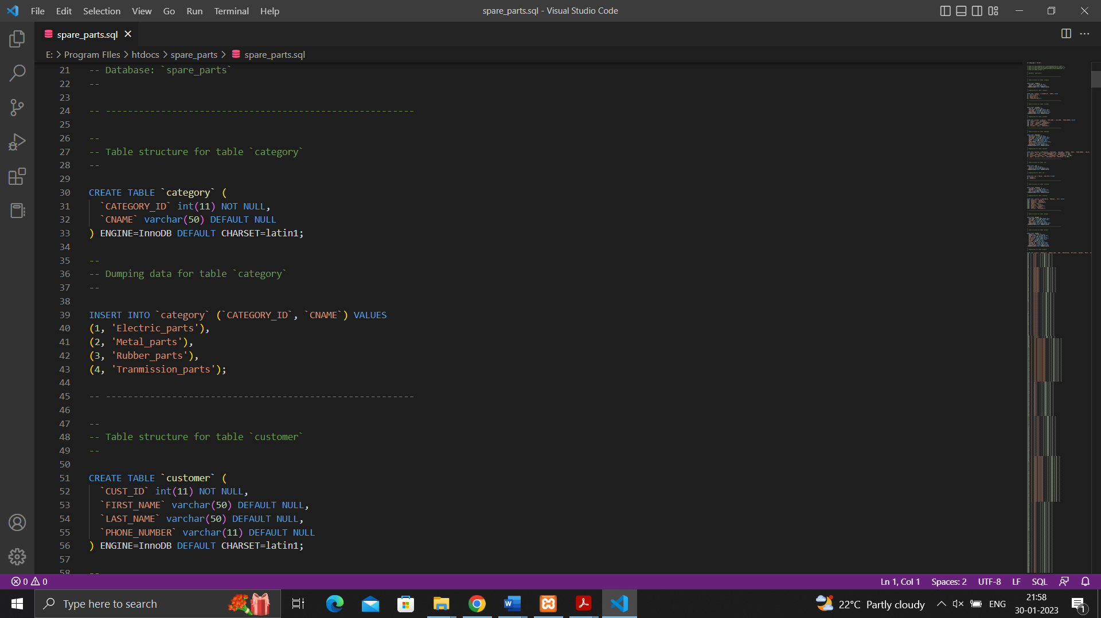

Screenshot 5.15: Creation table of Category and customer.

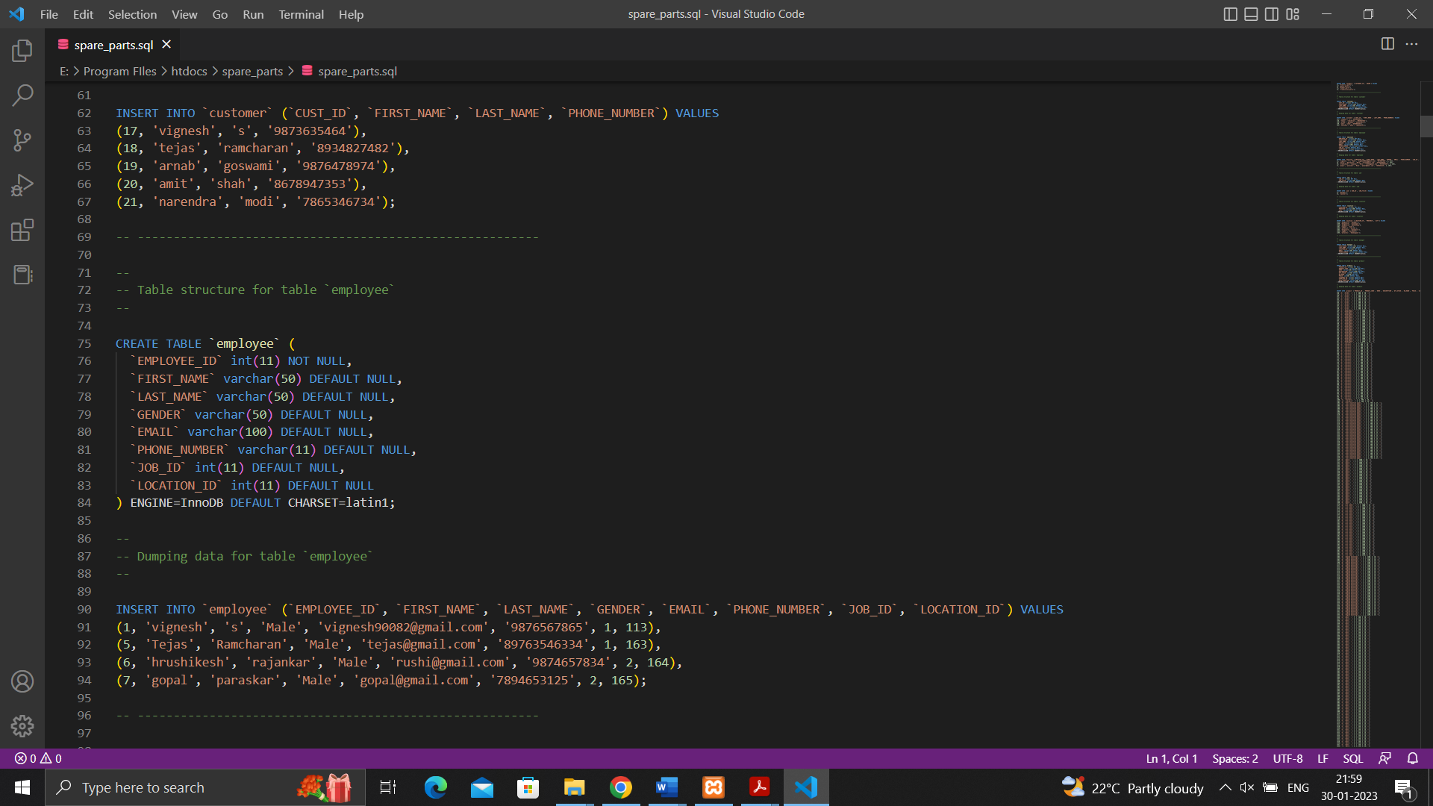Screenshot 5.16: Creation table of employee.

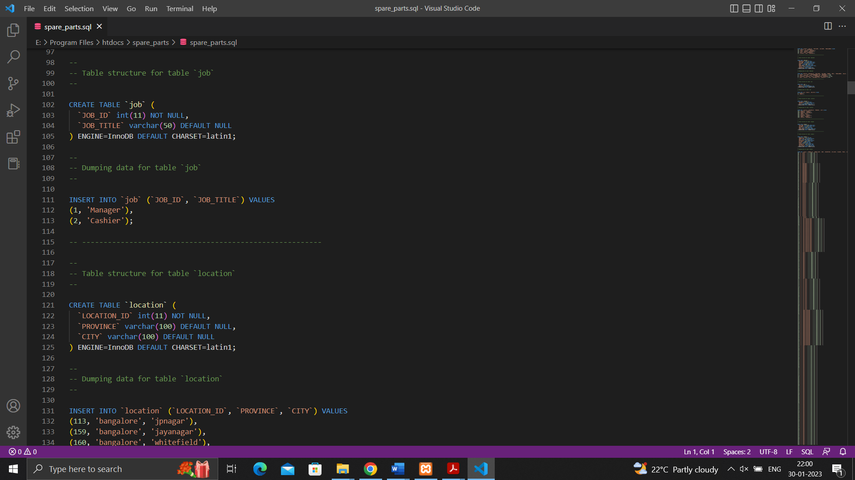Screenshot 5.17: Creation table of Job and Location.

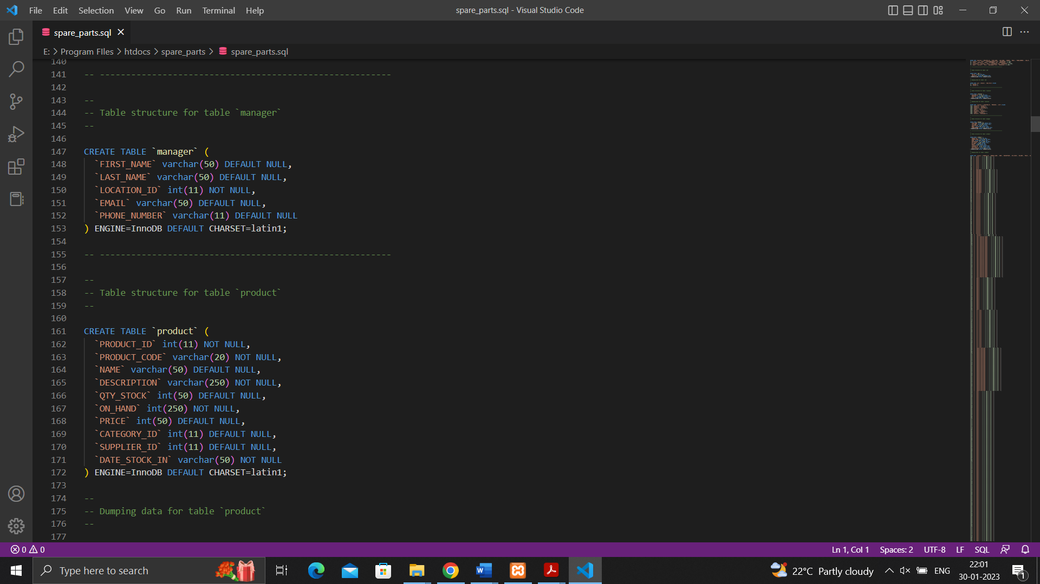Screenshot 5.18: Creation table of Product and manager.

Details of all kinds of products and list of managers to be created

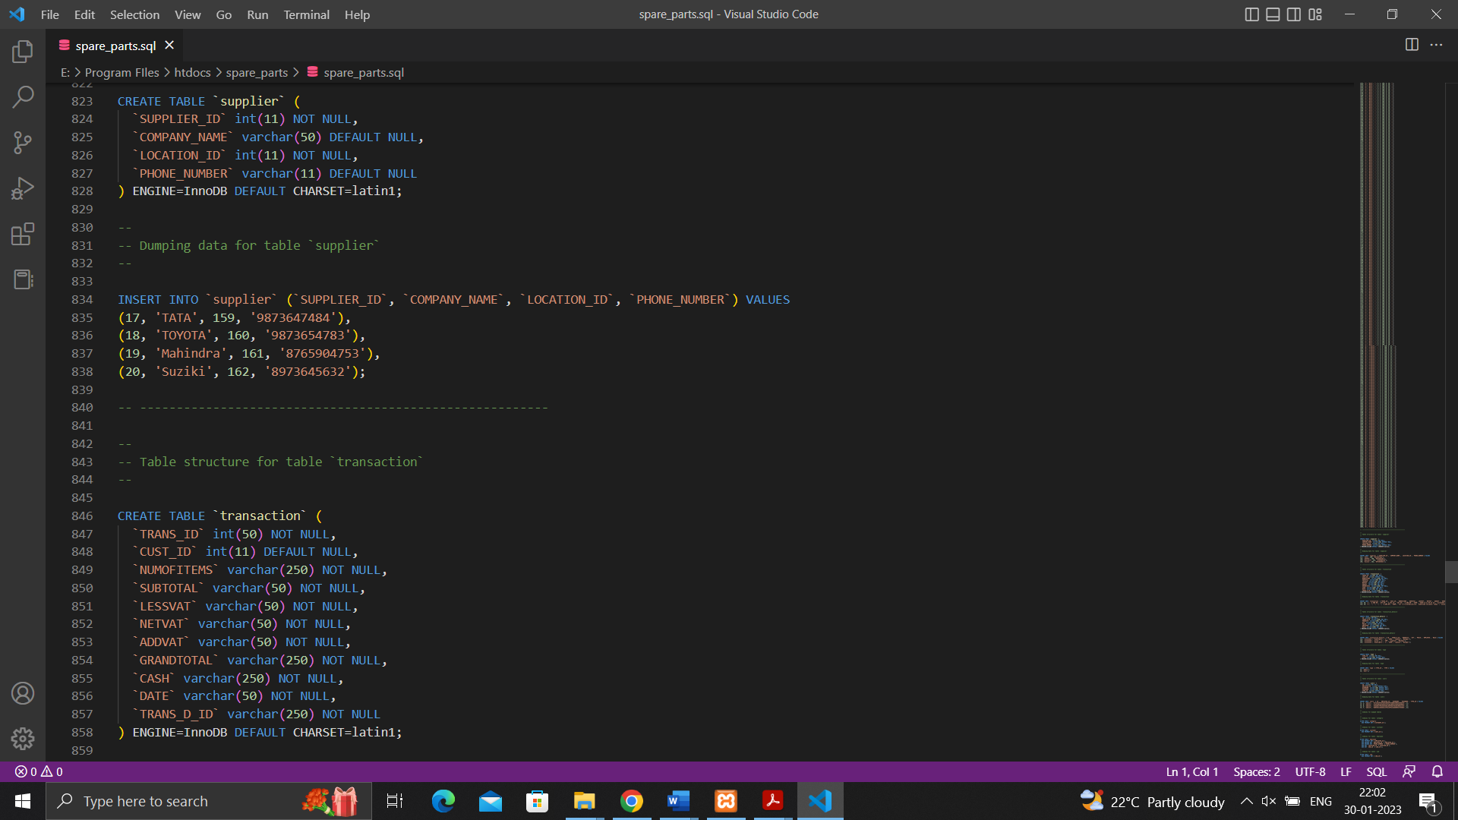Screenshot 5.19: Creation table of Supplier and Transaction.

To keep an record of all suppliers and transaction history.

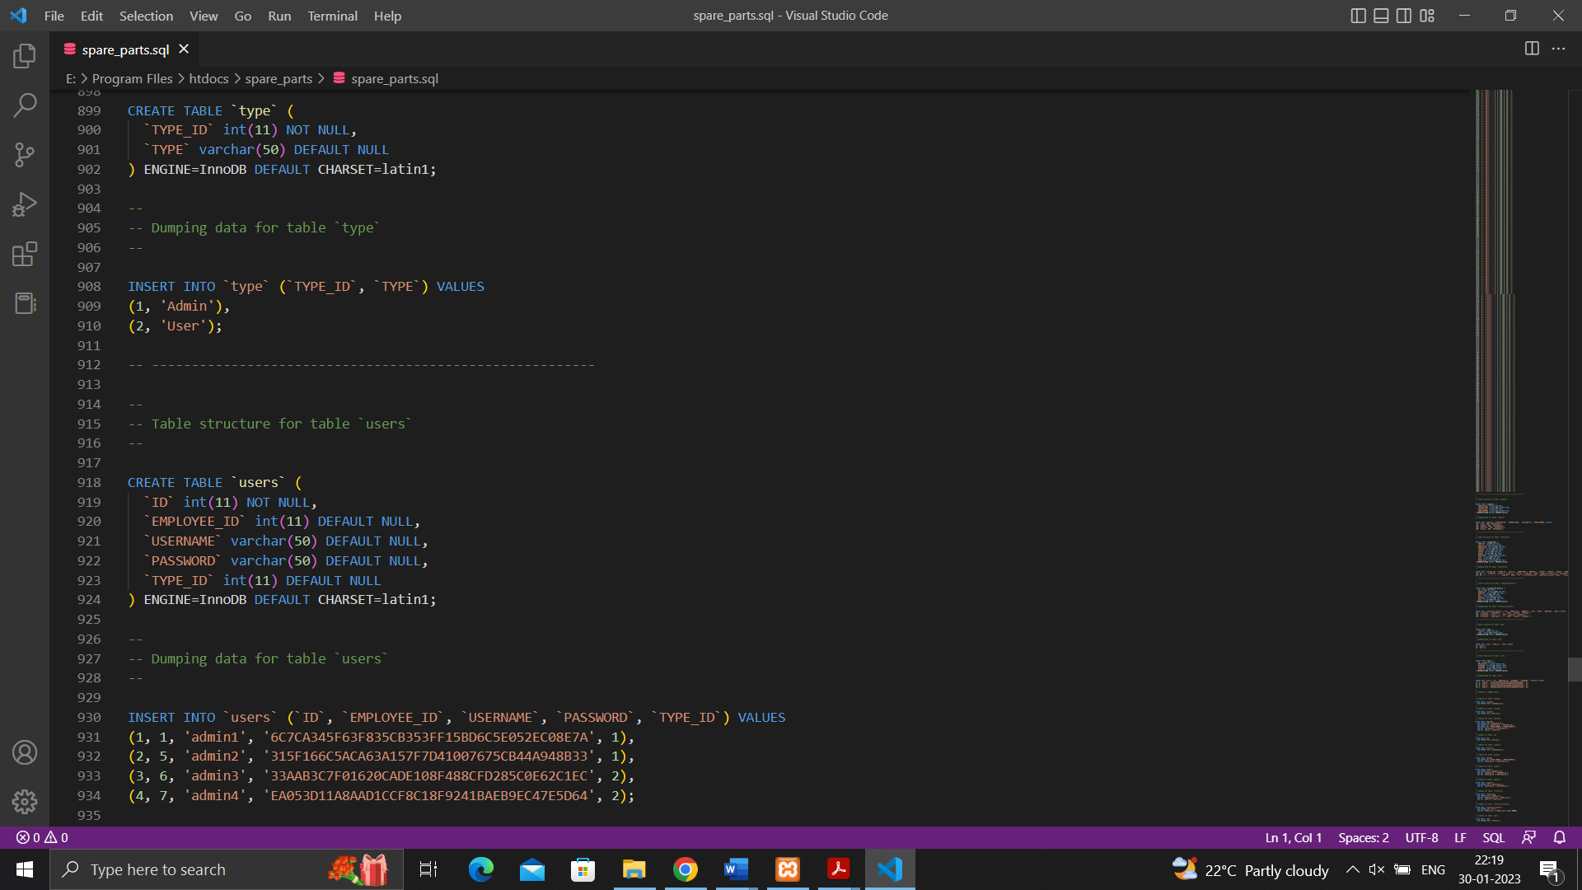Screenshot 5.20: Insertion Values of Users and Type.

All the data of Users using the website and type of products can be found.

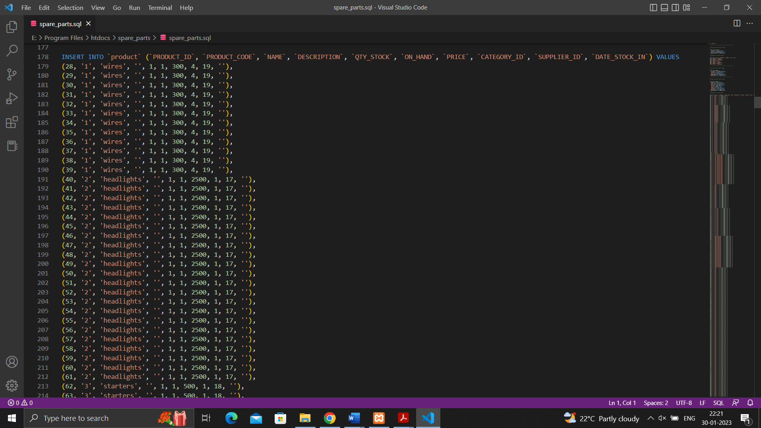Screenshot 5.21: Insertion Values of all kinds of spare parts.

All the data of the spare parts which can be ordered from the website are been inserted.

**CHAPTER 6**

**CONCLUSION AND FUTURE ENHANCEMENTS**

**Conclusion:** At last we want to conclude that this application will decrease the overhead of the owner of the shop. It will be easily able to monitor the available stock present in the shop. It 0 also helpful for the owner that whose money is pending or how much he has to pay to the supplier. The main motivation behind this application is to reduce tension and easily monitor the current condition of the shop. Now there is no need of books and paper in the shop and manually keep track of each record.

**Future Scope/Enhancement:** As you see, IT industry is booming the industry from last few decades. It will keep on booming as you go on and on. As you see our project is limited to one user\owner. But, we can further expand this to multi-user to multi-customer and there is way we can do that. We all know that there and various online shopping application and website available for their basic need. But, there is no application or website available for the Automobile Spare Parts. These were we can enhance this project further. We can make an application like Amazon were you get every single piece of the spare part on your application and need to go anywhere to find it. By providing the best product at best prices everyone going to come and visit the site. We can show the picture of the product with the offers on the particular occasion.

We can also add the feature that how amount of work has been done by the employee at your shop and how leaves taken by him/her. We can also add online payment methods with the help of Google Pay, PhonePe etc.

**REFERENCES**

# http://docs.oracle.com/cd/B12037_01/server.101/b10739/create

# http://docs.oracle.com/javafx/index.html

# http://stackoverflow.com/questions/15482623/javafx-1-3-listview

# http://stackoverflow.com/questions/8392119/javafx-1-3-crud-using-listview

# http://docs.oracle.com/cd/E17802_01/javafx/javafx/1.3/docs/api

# https://www.tutorialspoint.com/php/index.htm

# https://www.w3schools.com/php/DEFAULT.asp

# “Database System Concepts” by Henry Korth.

# “Mysql” by Paul Dubois.